TEAM CAPTAIN REGISTRATION: It is highly recommended that you have emails ready for those you want to invite to your team right away. However, you can manage your roster at a later time by going back to your “Dashboard" in your account.
Step 1: Find the League on the Seacoast United Sports Club website, click on the blue register button.
• If new to league apps – will need to create a profile
• If existing league apps – sign in.
Step 2: Register as a Team Captain
• Fill out required information
Step 3: The registration fee will be split according to the number of players on the team. Please make sure at the time of registration to make a good guess of the number of players that will be on your team for the season.
IMPORTANT: If you do not know the amount of players that you will have on the team or you think it will change, take the payment on as the captain. You cannot change the split after you have chosen to split the team fee by a certain amount of players. You will still need to invite your players in Step 8.
Once you have a confirmed number of players, you can reach out to Rachel Gagnon (Rachel.gagnon@threestep.com) or Owen Willis (owen.willis@threestep.com) to create invoices for your players. This will help mitigate players paying the wrong amount.
Step 4: Choose a division
Step 5: Payment Method – the payment is the amount due by each individual based on # of players on the team
• If you choose to pay later – payment can be done from your dashboard
Step 6: Confirmation of registering – before clicking away – click on “Go to your Dashboard” to immediately start inviting players to your roster. You will also receive an email after registering, where you can click on “Manage Team”:
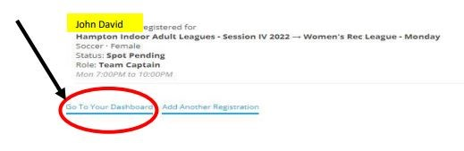
Step 7: Getting to your roster from your dashboard
• Under Role/Team Click on you “Manage or Add Players”, this will bring you to your roster page.
Step 8: On the “Roster” page, hover over “Invite” at the top of the page.
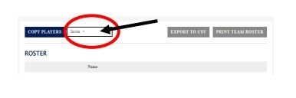
Step 9: Type emails for each player you want to invite to your team, one email per line
• Pending invites will show under the “Invite” in the second drop down option

PLAYER RECEIVING INVITE:
Step 1: Player will receive an email invite.
• Create a League App profile or sign in with an existing account
• If creating a new profile – complete your profile information
Step 2: On your dashboard – click “Accept” to join the roster
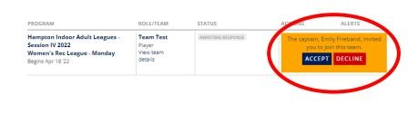
Step 3: Registration Details & Waiver/Player Code of Conduct,
Step 4: Payment

