How To Register Your Team for Youth League

Highly recommend registering on a laptop and please read through before registering.

Click on the “Register” button and then choose which age group for your team.

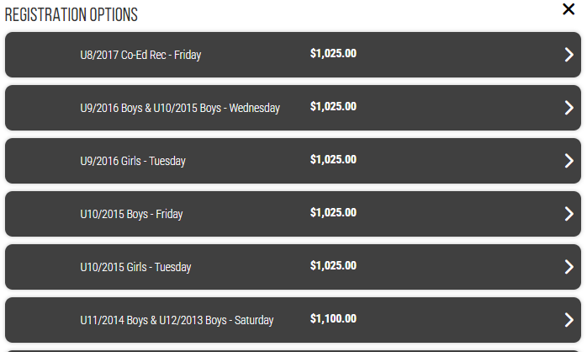

It will prompt you to log in to Playerfirst, if you have an account, you may use that one. Or you can click on Create an Account and go through the process of creating one.

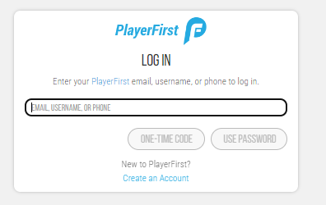

Once you log in or create an account, there should be one guardian in the account, click on the next button in the bottom right corner.

Continue to next page

You will then be asked to add the team information: team name, coach name, coach email, phone number, if you are the team manager, please toggle the box, team hometown, and team home state.

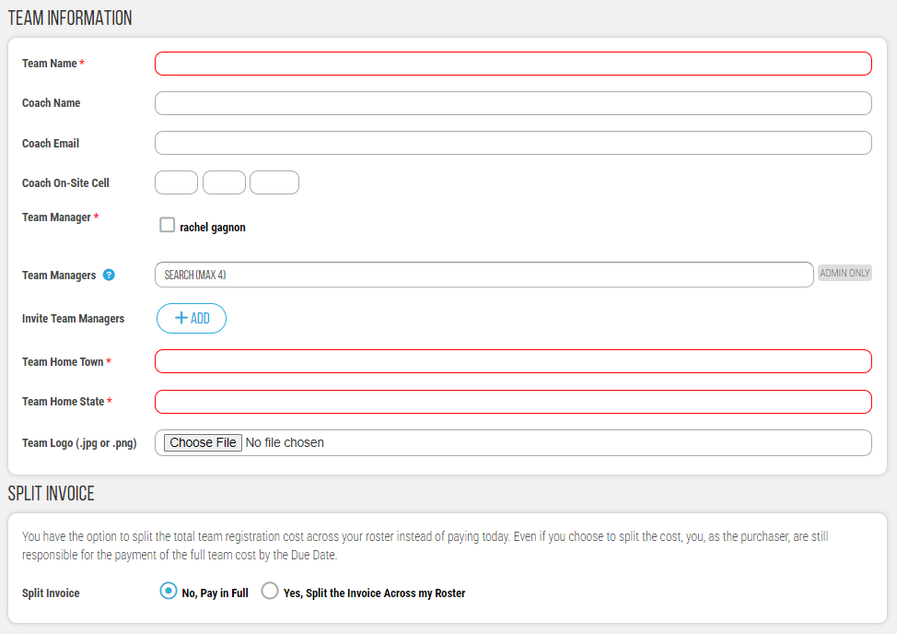

IMPORTANT STEP:

On the same page as inputting the team information it will ask if you want to pay the invoice in full (your team would then pay you back personally) or you can split the invoice by your roster.

You do not need to know many players you will have right away to choose the split invoice option.

Once you finish with the team information page, click next and it will prompt you select which division you would like you team to play in and to sign waivers.

If you choose to pay in full, the next page will be for payment options. If you choose a split invoice, it will walk you through to complete the order. Be sure to click on COMPLETE ORDER
  - Please note that you will only be charged $0.00 by CC or $0.01 by ACH to establish an authorization at this time. You will then have to go in to the ‘Teams’ tab of your PF account and upload your roster. From there, you can split invoices evenly amongst your team.

You will get a confirmation page and from there you can start adding to your roster by clicking on MY TEAMS. If you are going to add your roster at another time, when you log back into your account, click on my teams and then follow the steps below.

You will need a player First and last name, jersey # (this doesn’t have to be accurate, you can put in any jersey number) and a player’s birthdate (this should be as accurate as possible), and email address.

Continue to next page

Adding a roster and any time you need to make changes, click on the + sign or pencile icon (the i button is to edit team information only) and you will be directed to your roster page. Click on the ‘add to roster’ button. It will prompt you add the number of athletes you will have on the roster and enter information manually or to upload a roster via a CSV file import.

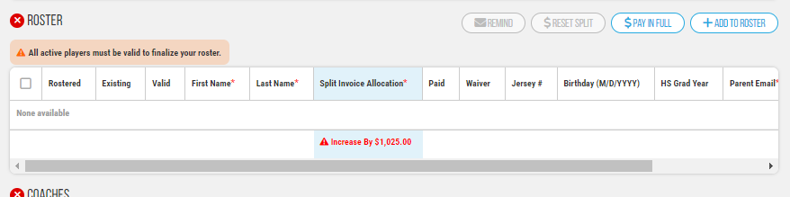

- Once you choose how many players you will have on the roster, you will see a roster with no player information: make sure to click save at the top once you input all of this information.
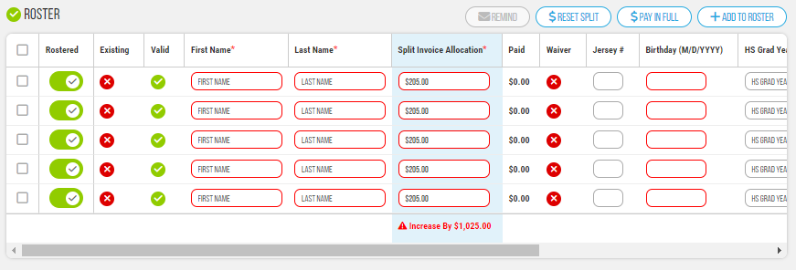
The system will automatically split the invoice by the number of players that you inputted; however you can customize it based on your preference. It will also notify you if you are equal to the invoice amount or if you have not reached the correct amount to be invoiced.
- You can add additional coaches as well to the roster;
- 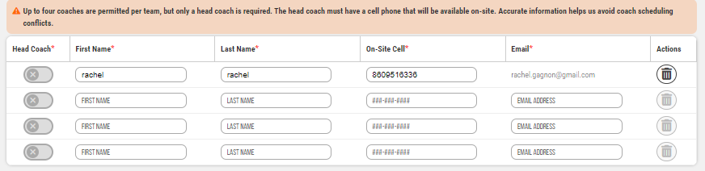

Continue to next page

A few notes on split invoicing:
- If you put 10 players on your roster, but you end of having 11, you can add that 11th player and reset the split based on the new number of players. Even if someone has paid, you can reallocate, and they will have a new balance for the difference. For example, if X paid $78 but the split is now $90, you need to put $90 in the allocation box, and it will now show a balance on their account for the $12.
- If players do not pay by a certain date, the remaining balance on the account will be charged to the coaches card on file.
- To monitor if players have paid (only pertains to those that paid by credit card or ACH), when you have logged back into your account, click on teams, click on the pencil icon and you can see who has paid by the green check mark in the split invoice allocation column.
- You can also send reminder emails by clicking on the remind button on the roster page as well. You can send reminder emails for waivers and invoices.

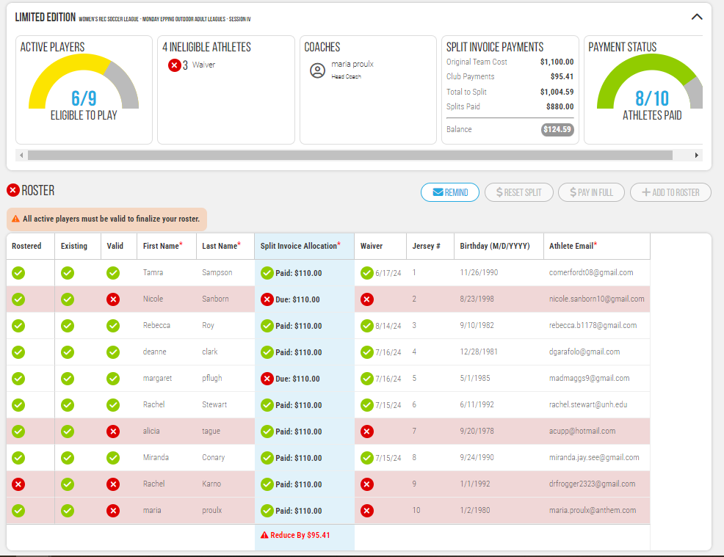
- If someone is paying by check or cash at the facility it will only be linked to the overall invoice. It is highly encouraged to pay by credit card or ACH. If a player will be paid by cash or check, please make sure they write the team name and their name on the check and provide that to the front desk staff so it can be correctly applied.
When registering for a second session – you can copy the roster over and if you don’t want to have a player included, you can toggle them in the edit roster function, it is the first column on the left and they will be left off the roster and split invoicing.

